

GAME DESIGN DOCUMENT

for

Escape Dash
–GROUP 1–


Member
Name | Student code
Nguyễn Đình Lộc | HE194983
Nguyễn Cảnh Mạnh Linh | HE194022
Chu Bảo Khang | HE190295
Nguyễn Anh Tú | HE191801

1. Project Overview
Escape Dash is a 3D endless runner inspired by the gameplay of Subway Surfers. The player runs automatically through an environment, avoids obstacles, collects coins, and attempts to survive for as long as possible.
The project is designed as an achievable Unity prototype. The prototype includes automatic movement, three-lane navigation, jumping, sliding, obstacles, collectibles, scoring, progressive speed, camera follow, menus, pause, Game Over, and restart.

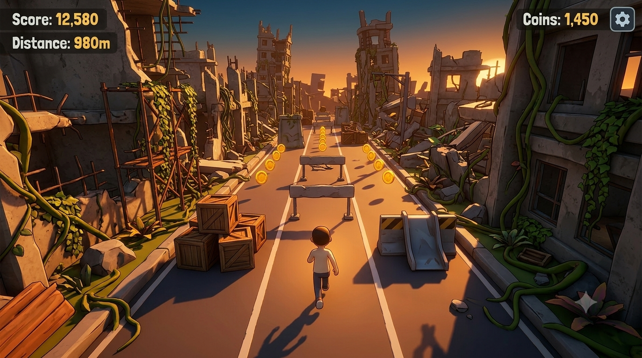
(Example picture)

2. Game Concept

2.1 Game Name
Human rush

2.2 Genre
3D Endless Runner

2.3 Game Elements
- Automatic forward movement
- Three-lane navigation
- Jumping and sliding
- Obstacle avoidance
- Coin collection
- Distance and score progression
- Increasing movement speed
- Environment

2.4 Player Count
Single-player. One player controls one runner during each attempt.

2.5 Game Identity
The central identity of Escape the Ruins is fast, readable, and repeatable gameplay. The player should understand immediate danger, make quick decisions, and feel that improvement comes from practice.

3. Technical Specifications
3.1 Technical form
3D graphics with a simple graybox/prototype visual style

3.2 Camera View
- Third-person follow camera behind and slightly above the player
- Possible one-sided (2d view) camera for better player experience

3.3 Target platform
Currently for PC. Can be developed for mobile if possible.

3.4 Development Engine
Unity.

3.5 Programming Language
C#

3.5 Input

Input | Action
A / Left Arrow | Move one lane left
D / Right Arrow | Move one lane right
Space | Jump
S / Down Arrow | Slide
Escape | Pause

3.5 Prototype scope
One playable environment, one player, reusable track segments, basic UI and feedback

4. Gameplay Description
When the player launches the game, the Main Menu displays the title and a Play button. After starting, the character immediately begins running forward along a three-lane track. The player observes the upcoming path and reacts by changing lanes, jumping over low obstacles, sliding beneath overhead barriers, or collecting coins placed in safe or risky positions.
The track is composed of reusable segments. As the run continues, the game introduces more frequent obstacles, more complicated patterns, and gradually higher speed. The player balances safety and score: collecting coins may require moving toward a dangerous lane, while staying alive remains the primary objective.
The run ends when the player collides with a damaging obstacle. The Game Over screen shows final score, distance, and coins, with options to restart or return to the Main Menu.

5. Player Goal and Motivation

5.1 Main Goal
Survive as long as possible and achieve the highest possible score.

5.2 Secondary Goals
- Collect coins
- Reach distance milestones
- Improve reaction time and route recognition
- Beat previous high scores
- Learn obstacle patterns through repeated attempts

5.3 Why the Game Is Fun
- Simple controls
- Short replayable sessions
- Immediate feedback
- Increasing tension as speed rises
- Personal improvement (Challenge)
- Risk-versus-reward decisions

6. Core Gameplay Loop
- Start the run
- Automatically move forward
- Observe the upcoming track
- Choose to change lanes, jump, slide, or continue
- Avoid obstacles and collect coins
- Receive score, distance, and feedback
- Adapt to increasing speed
- Continue until collision
- Review results and restart or return to Main Menu
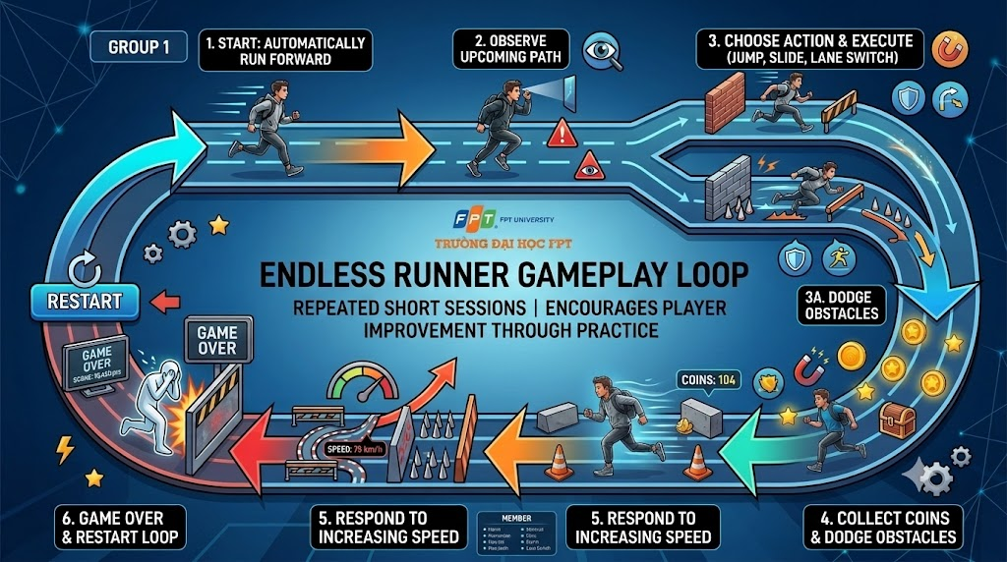

7. Player Definition

7.1 Player Character
The player controls a runner attempting to escape through the environment. During grayboxing, the character is represented by a capsule or placeholder model.
There are many Characters in the game with different stats and challenges. Players can choose different runners for a better experience.

7.2 Player Actions
- Run automatically forward
- Move left or right lane
- Jump over low obstacles
- Slide beneath overhead obstacles
- Collect coins
- Pause/Restart after Game Over

8. Game Rules and Definitions
- Player remains within three lanes
- Player cannot leave the track
- Low obstacles are avoided by jumping or changing lanes
- A damaging collision causes Game Over
- Collected coins disappear and increase the counter
- Distance contributes to score
- Speed gradually increases
- There is no traditional final level
- Pause and restart are available

9. Player Rewards and Pickups

9.1 Coins
Coins are the primary collectible. They appear in lines, groups, or optional risky positions. Collecting a coin increases the coin counter and provides visual and audio feedback.

9.2 Optional Future Pickups
- Temporary shield
- Coin multiplier
- Coin magnet
- Temporary speed boost

9.3 Special “Object”
Special objects are the secondary collectible. They are rare, but contain much more value than coins. Can act as a challenge to player..

10. Level Flow and Difficulty Progression
Although the game is endless, difficulty is structured into gradual phases.
Phase | Track Design | Obstacle Design | Player Experience
Opening | Safe and readable | Few or no obstacles | Learn controls
Early Run | Simple reusable segments | Single clear obstacles | Build confidence
Middle Run | More varied patterns | More frequent combinations | Require faster decisions
Late Run | Higher speed and denser patterns | Complex but readable combinations | Create tension
Endless Continuation | Shuffled/reused segments | Difficulty continues fairly | Encourage personal-best attempts
Difficulty must increase fairly. Obstacles should not create unavoidable combinations, and the player needs enough time and space to react.

11. Graybox Objects
- Player capsule
- Three-lane track
- Low cube obstacles
- Overhead bar obstacles
- Coin placeholders
- Third-person follow camera
- Reusable track segment prefabs
- Simple environmental blocks
- Canvas UI
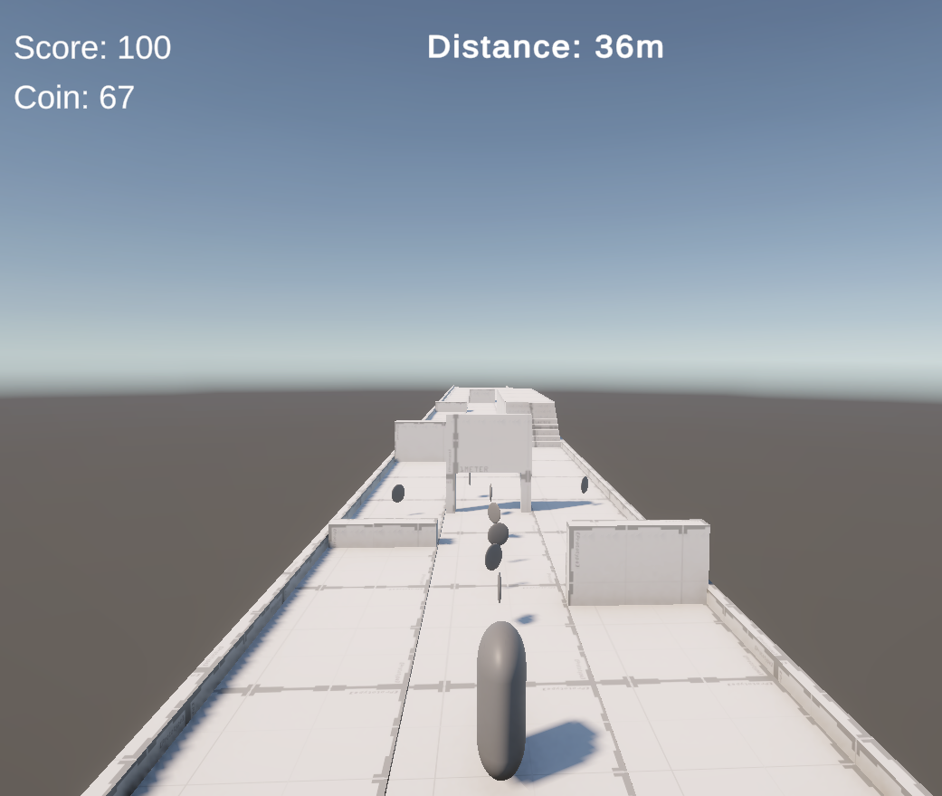.

12. User Interface and User Experience

12.1 Main Menu
- Game title
- Play button
- Controls panel
- Optional Quit button

12.2 Gameplay HUD
- Score Distance
- Coin counter
- Pause button
- Distance indicator

12.3 Pause Menu
- Resume
- Restart
- Return to Main Menu
- Main Menu button

12.4 Game Over Screen
- Final score
- Distance
- Coins
- Restart button

13. Win and Lose Conditions

13.1 Winning / Success
Because Escape Dash is endless, there is no traditional final level. Success is measured by survival time, distance, coins, and score. Optional milestones include surviving three minutes or reaching 1,000 points.

13.2 Losing
The player loses after colliding with a damaging obstacle. The run stops and the Game Over screen displays final results.

14. Prototype Purpose and Evaluation

14.1 Prototype test
The prototype tests whether the central gameplay loop is functional, understandable, and enjoyable.
- Automatic movement
- Jump and slide mechanics
- Obstacle reusing placement
- Lane switching
- Obstacle collision
- Coin collection
- Score and distance calculation
- Speed progression
- Camera following
- Menu, HUD, Pause, and Game Over states
- Restart and return-to-menu functionality

14.2 Playtesting Questions
- Can new players understand the controls?
- Are obstacles readable?
- Is reaction time sufficient?
- Does difficulty increase gradually?
- Are coins tempting but fair?
- Does the player understand why Game Over occurred?
- Are lane spacing and graybox dimensions comfortable?

15. Scope and Limitations

15.1 Included
- One player
- One track theme
- Three lanes
- Automatic running
- Lane switching, jumping, sliding
- Basic obstacles and coins
- Score, distance, coin counters
- Increasing speed
- Main Menu, Pause, HUD, Game Over, Restart
- Simple graybox environment for testing

15.2 Excluded (Future development)
- Multiplayer
- Combat and enemies
- Multiple characters
- Large story campaign
- Online leaderboards
- High-end final art

16. Conclusion
Escape Dash is a focused and achievable 3D endless-runner prototype demonstrating the transition from a game concept to a playable Unity graybox. The document defines the game's content, player interaction, difficulty progression, interface, success and failure conditions, scope, and evaluation approach.

